PRE-COP 26 HYBRID WEBINAR at DIAMNADIO-Dakar
September 22, 2021 – Meeting summary report

I. Background
As a part of the preliminary discussions for the World Water Forum on March 22, GGGI in collaboration with the World Water Forum Executive secretariat, are hosting a series of webinars that highlight sanitation in the “Forum of Responses “concept.
This session was also developed in conjunction with the upcoming COP26 objectives, whose focus is to support countries on their ecosystem’s restoration and protection, infrastructures development, resilient agriculture and raising financing for all mentioned. The objective of this Pre-COP 26 event was to emphasize needs and opportunities in developing resilient on-site sanitation systems with low carbon emissions as part of the solution.
The webinar brought together key stakeholders to discuss about this water-related component and challenges to achieve SDG6.2. The objective was to feature the link between sanitation and climate change.
Format:
A half day of hybrid sessions was held with both presential, and virtual assistance of specialized organizations and institutions involved in designing policy approaches, implementing and development partners. Two (02) virtual sessions were held, the first in French and the second in English.

II. Welcoming remarks – key messages

Mr. Amadou Ndiaye – Technical Advisor of the Executive Secretariat of the World Water
The event was initiated emphasizing the importance of mobilizing stakeholders in this important Pre-COP event, ‘road to Dakar’ to be held March 2022.

Mr. Romain BRILLIE, GGGI Senegal Country Representative
GGGI as an intergovernmental organization is dedicated to the emergence of green and inclusive growth in developing countries. Green growth as a rapid and definitive transition to low-carbon and inclusive economies must enable the most vulnerable populations to benefit from these development policies. It is therefore a question of accelerating the termination of two major global agendas, one part the climate agenda of the Paris Agreement and the NDC and the other part the 2030 Agenda through the achievement of the Sustainable Development Goals. The convergence of his two agendas is being addressed in this event focusing on the importance of the sanitation sector on climate change.

Ms. Victoria BILLING, H.M Ambassador of the United Kingdom to Senegal and Cabo Verde

Sanitation and climate change are closely interlinked
Greenhouse gases emissions from sanitation are considerable and increasing with the rapid pace of urbanization. A 2020 GGGI led study shows that Senegal onsite sanitation systems contribute nearly to 70% of emissions from the sanitation sector and represent up to 5% of national emissions. Yet these emissions can be reduced at a low cost.
One of the main sources of GHG emissions in sanitation systems according to studies from the University of Leeds and GGGI, is through the anaerobic containment of fecal sludge. Climate change is also increasing the vulnerability of sanitation infrastructure and water resources to climate change. The combination of increased flooding and poorly constructed and maintained containment systems causes increased contamination of water sources. In view of on-site systems accounting for over 80% of Senegal’s sanitation infrastructure, as well as in many LMIC countries across the world, there is a dire need to better understand and improve the climate impacts of on-site systems.

Senegal is a forerunner in including sanitation in its climate policy
Senegal has been a forerunner in sanitation in the sub-region. It has included sanitation mitigation and adaptation targets in its nationally determined contributions submitted in 2020 to the UNFCCC, when only 2% of the world’s countries currently have sanitation activities in their NDC.
Data availability is key for Senegal, to keep making progress in providing safe access to sanitation and meet its SDG6 target as included in the Plan Sénégal Emergent. In view of the increasing pressure from climate change on scarce water resources, safe access to sanitation is intricately linked to increasing the resilience of populations in Senegal.

The SCARE project aims to develop a better understanding of linkages between sanitation and climate
The “Ecole Polytechnique de Thies” in Senegal is a key partner of the project, together with international research institutions such as the Universities of Bristol, Leeds and Sydney. Together, they will contribute to providing a new, highly replicable methodology to assess emissions from sanitation from different technologies and management options, with a view at having these adopted by national and international stakeholders.

The coming COP26 is an opportunity to highlight sanitation’s contribution to climate mitigation and adaptation
Considering the coming COP26 focuses on supporting countries in protecting and restoring ecosystems, building resilient infrastructure and raising the necessary financing to implement the Paris Agreement; Building linkages between climate change and sanitation policy agendas, as well as with climate financing, can contribute to countries achieving both their NDC targets and SDG6.

Mr. Abdoulaye SENE Executive Secretary, World Water Forum Executive Secretariat (on-line) (full notes available)

Dissemination of Senegals experience as part of the World Water Forum 2022
The organization of the 9th World Water Forum, to be held in Diamniadio in 2022, will be the first to be held in sub-Saharan Africa; is a unique opportunity to promote and disseminate Senegal's experience on this subject. Sanitation is a global issue with 873 million people worldwide do not have access to basic toilets and practice open defecation. Poor management of wastewater and excreta causes significant damage to the environment. Through the integration of sanitation in its NDC, the SCARE project and strategies and policies of the sector, Senegal will be one of the few countries to have really taken the measure of these issues.
On the 14 and 15 October discussions on the orientation of the content for the World Water Forum will be held, all stakeholders to take part in this retreat.

COP26 and current context
In the context of the post COVID19 economic and social crisis, it will be more important than ever to link climate action and investment in sectors with high social and development impact, such as sanitation.

Press briefing
Ms. Victoria BILLING was asked about climate change policies and how they relate to sanitation. She also noted the importance of working with these partners on mitigation and adaptation to the effects of climate change integrated into sanitation policies. She reassured that Great Britain has doubled its contribution to the international climate fund to 11 billion for the next 4 years with which Senegal has access for its projects such as sanitation.
Mr Abdoulaye SENE in his interview recalled that the DA with GGGI have already carried out a study already restored which allowed them to know more and more the contribution of sanitation in greenhouse gas emissions. This is a first step. A Containment Standard has also been certified and is part of the implementation of climate resilient sanitation infrastructure.
Mr Romain BRILLIE also explained the importance of being able to quantify emissions from autonomous sanitation facilities. The circular economy is also very important for the reuse of wastewater by-products such as energy, which will produce biogas that will reduce greenhouse gas emissions from wastewater systems.

III. Session I Moderated by Ms. Marème Ndour - Country Coordinator COY16

Ms. Nathalie ANDRE, Specialist, Sanitation, GGGI (ppt available)
SCARE project is being implemented by a consortium led by the University of Bristol and includes 6 research institutions (U. Leeds​, U. Katmandu, U. Kyambogo, ​U. Haramaya, U. Sydney​, U. P. Thiès​) and GGGI. GGGIs role globally is to support member countries in developing inclusive green economies and will have the same role in SCARE, helping countries use key research outputs in policy on their path to green growth.

Summary of SCARE project globally with two main objectives: 1. A better understanding and data sets of emissions from on-site sanitation systems as well as methodologies for LMICs to replicate 2. A better understanding of resilience and on-site sanitation systems.
Dr. Oumar Sene, Director of Sanitation, Ministry of Water and Sanitation of Senegal
The State of Senegal has integrated sanitation into its climate change programme. The Ministry of Water and Sanitation is in the process of developing the national disaster risk reduction strategy. The Sanitation Directorate and the Ministry of Water and Sanitation are also taking sanitation into account in disaster response at the Ministry of the Interior level.
Mr. Libasse Ba, President, COMNACC
Mr. Libasse Ba, spoke on the contribution of research to the climate change agenda in Senegal. He recalled that it was research that was the first to alert the international community on climate change through the first IPCC report of 1990.
The research has also proved data to make people understand that the world is experiencing climate change.
At the national level, research has enabled Senegalese researchers to measure the impacts and vulnerability of its climate change. He also showed the cloud on greenhouse gas emissions from remediation of 2% or 5%. It also showed the link between research and the private development sector in order to be able to take advantage of the opportunities of sanitation and apply new technologies and innovations to strengthen its resilience in the face of climate change training term.
Senegal has made conditional and unconditional commitment to the international community signing up to the Green PES and NDC. This research funding of the SCARE project fits perfectly into Senegal’s support in fulfilling its commitments.
Dr. Becaye Diop, General Director, DELVIC Sanitation Initiatives
The contribution of the private sector to the resilient management of wastewater systems is significant. On-site sanitation management in the sanitation sector in Senegal is particularly significant where 80% at the urban level and 100% at the rural level of houses in Senegal use on-site systems.
Senegal has limited financial means to develop and manage sewage networks. It is therefore necessary to organize non collective sanitation, modernising it to the benefit of the populations, from the health point of view and resilient to the impacts of climate change.
For the treatment of sewage sludge, it showed that Africans in particular Senegal are behind in addressing this challenge.
There are at present 11 fecal sludge treatment plants (FSTPs) in Senegal of which 4 are in Dakar, this shows that the private sector must invest in the construction of FSTPs and for this it is necessary for African states to facilitate the obtention of land, tax incentives, but also that international investors and foundations agree to support the private sector. H Africa has all the expertise needed to be autonomous in the design and construction of FSTPs.

IV. Session 2 Moderated by Mr. Romain BRILLIE, GGGI Senegal Country Representative
Brian Arbogast, Director – Bill and Melinda Gates Foundation (video message available)
The work carried out by the University of Leeds for the CACTUS project in Uganda revealed that on-site sanitation emissions were severely underestimated. As countries look to increasingly include sanitation targets in their NDC methods to evaluate emissions from on-site need to be improved; SCARE can contribute to this.
In view of the risks to sanitation systems to climate change, innovation is needed in technology but also in planning approaches and tools (such as SCARE) to better equip countries in developing resilient sanitation systems.

Professor Guy Howard, University of Bristol (ppt and resilience brief available)
The resilience work will address the issue of climate change posing a major risk to WASH beyond current sustainability. A methodology was developed by the SCARE consortium comprising of 50 key indicators covering the 6 key domains of resilience. Data will be collected in Nepal, Ethiopia and Uganda.

Professor Barbara Evans, University of Leeds (ppt and emissions brief available)
The emissions work builds on the CACTUS project where measurements of GHG emissions were taken in Kampala and revealed that anaerobic on-site sanitation systems emitted over twice the amount estimated with current IPCCC methods. In view of high use of such on site systems a better understanding is needed of the emissions to enable a safe but low emission service.

Professor Baba Ngom, Ecole Polytechnique de Thiès (ppt and video available)

The site selection in Senegal has been carried out in Kaolack and Tivouane. Emissions will be measured over different seasons once the equipment has been calibrated and validated by the research consortium. The video describes the different equipment and process in detail.

Mr. Hubert Jenny – Senior Infrastructure Specialist, Green Climate Fund (notes available)
GCF is preparing the Water Security Sectoral Guideline which creates a new asset class in sanitation and water re-use under two paradigm shifting pathways of:
Water conservation & water efficiency, including wastewater management mostly on Mitigation. This includes transforming waste into a resource: biogas; nutrient recovery; reduction of water and carbon footprints from Climate Smart Water and Sanitation Utilities and decentralized Wastewater Management with high efficiency package plants
Preservation of water resources consists mostly in adaptation projects and programs. One innovation the GCF is exploring is non-conventional water including wastewater as a new asset class through water re-use and water recycling. Other actions include preservation of existing water resources mostly from pollution requiring sanitation and preservation of water and sanitation infrastructures from water related hazards.
GCF will not finance a water project if there is no demonstrated plans at a strict minimum for sanitation and better with a parallel funding to the GCF funded water project…
Sanitation roadmap needs to be developed over time step by step: Japan took over 60 years and massive subsidies to achieve universal coverage in sanitation; Europe started in the 1970s with River Basin Agencies subsidizing sanitation programs.
Implementing Sanitation projects in whatever shape and form will contribute to climate finance in both mitigation and adaptation with major co-benefits economics, environmental and public health.

Ms. Jolly Ann Maulit - WASH Specialist, UNICEF
UNICEF has committed to shifting all its WASH programs globally to be climate resilient. A strategic framework for Climate Resilient WASH was developed in collaboration with the Global Water Partnerships to build the capacity of staff and partners to make this shift. UNICEF’s West and Central Regional Office is supporting UNICEF offices and governments in the region to make this shift, to access the Green Climate Fund “Readiness” window (as a delivery partner), and to develop concept notes for the Green Climate Fund. Field work to examine climate change adaptation for sanitation is ongoing in Burkina Faso and will be scaled to additional countries. Additional programming and partnerships for climate resilient sanitation services will be strengthened in the incoming UNICEF Strategic Plan (2022 – 2025). UNICEF also supports governments and regional organizations (such the AMCOW) to integrate climate resilient sanitation services in WASH policies, and in policies of related sectors (e.g. environment).

V. Conclusion
As government and development partners increase efforts to address current challenges including those for sanitation, the wide dissemination and common language around challenges and solutions is needed.
This Pre-COP event brought together actors of the COP26, the World Water Forum as well as government and private stakeholders in Senegal and global experts and climate finance to articulate around the potential to contribute to the climate change agenda through research and policy including through the efforts of the global SCARE consortium.
Action is needed from all stakeholders and this needs to be based on accurate data, the active participation from all those at the meeting (despite technical issues) is one step forward which is to be continued during the COP26 and the World Water Forum in Dakar 2022.

VI. Agenda
September 22, 2021
09.00 – 09.30 | Welcome & Registration
09.30 – 10.00 | Welcoming remarks:  Mr. Romain BRILLIE, GGGI Senegal Country Representative  Ms. Victoria BILLING, H.M Ambassador of the United Kingdom to Senegal and Cabo Verde (on-line)  Mr. Abdoulaye SENE Executive Secretary, World Water Forum Executive Secretariat (on-line)
10.00 – 10. 15 | Press Briefing
10.15 – 11.10 | Session 1 - Sanitation facilities resilience to climate change: a need for improved management of services (French session)
11:15 – 12:10: Presentations  Presenter :  Ms. Nathalie ANDRE, Specialist, Sanitation, GGGI  12.10 – 12.40: Panel discussion  Panelists :  Dr. Oumar Sene, Director of Sanitation, Ministry of Water and Sanitation of Senegal  Mr. Libasse Ba, President, COMNACC  Dr. Becaye Diop, General Director, DELVIC Sanitation Initiatives  Moderator: Ms. Marème Ndour - Country Coordinator COY16 | Summary of the SCARE project – on-line presentation  Dialogue around Senegal’s integration of sanitation into its climate change program  Dialogue around the contribution of research to the climate change agenda in Senegal  Dialogue around the private sector contribution to the resilient management of sanitation systems
11.15 – 12.40 | Session 2 - Sanitation & Climate Change: Assessing resilience and mitigation of on-site systems (English session)
11:15 – 12:10: Presentations  Presenters:  Professor Guy Howard, University of Bristol  Professor Barbara Evans, University of Leeds  Professor Baba Ngom, Ecole Polytechnique de Thiès  12.10 – 12.40: Panel discussion  Panelists:  Dr. Baba Drame – Direction de l’Environnement et des Etablissements Classes (DEEC), Ministry of Environment and Sustainable Development of Senegal  Mr. Hubert Jenny – Senior Infrastructure Specialist, Green Climate Fund  Ms. Jolly Ann Maulit - WASH Specialist, UNICEF  Moderator: Mr. Romain BRILLIE, GGGI Senegal Country Representative | Video message from the Bill and Melinda Gates Foundation  SCARE Project summary with methodology used community’s resiliency with on-site sanitation systems- online presentation  SCARE Methodology used for GHG estimated emissions from sanitation systems – online presentation  Initial experience in testing by the Université Polytechnique de Thiès in Kaolack and Thiès for GHG emissions collection – presentation  Discussion with government and development partners (DEEC, UNICEF, GCF) and panelists from session 2
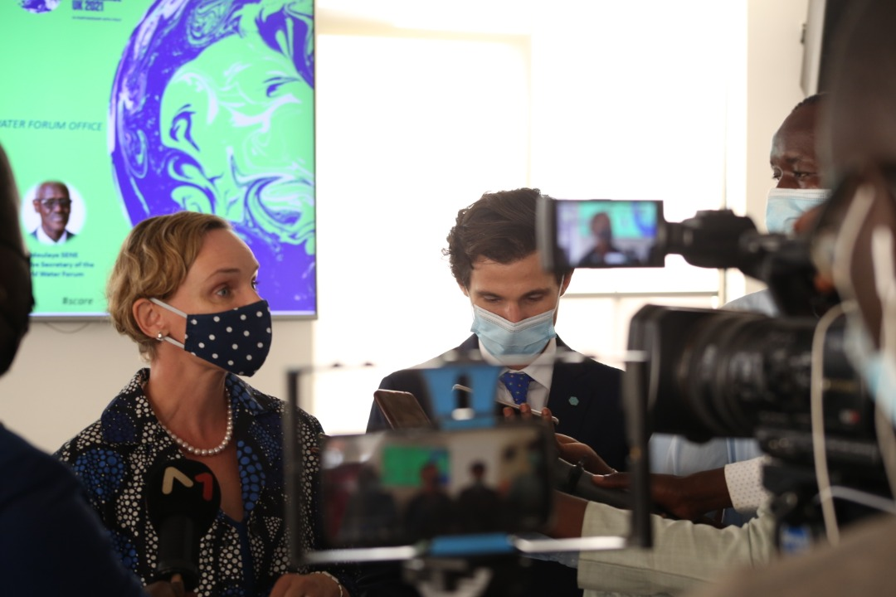

VII. Photos - opening session and press briefing

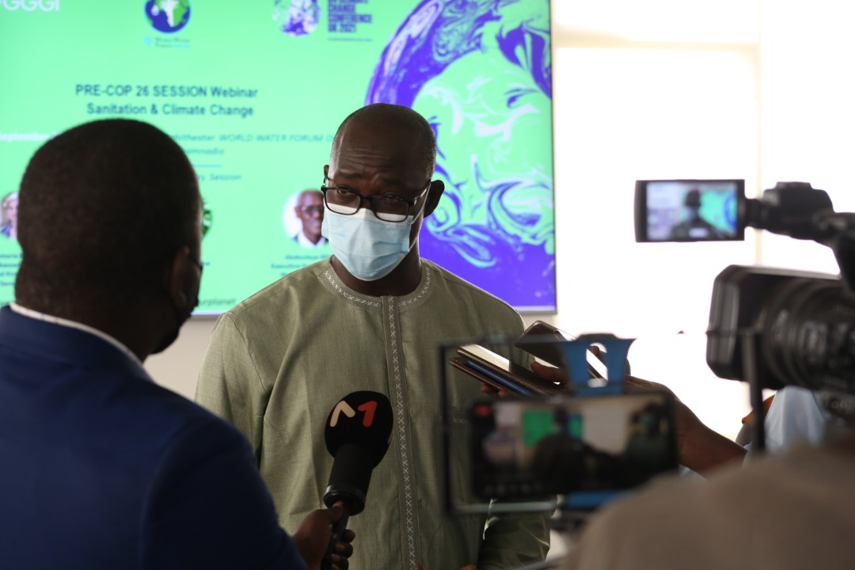

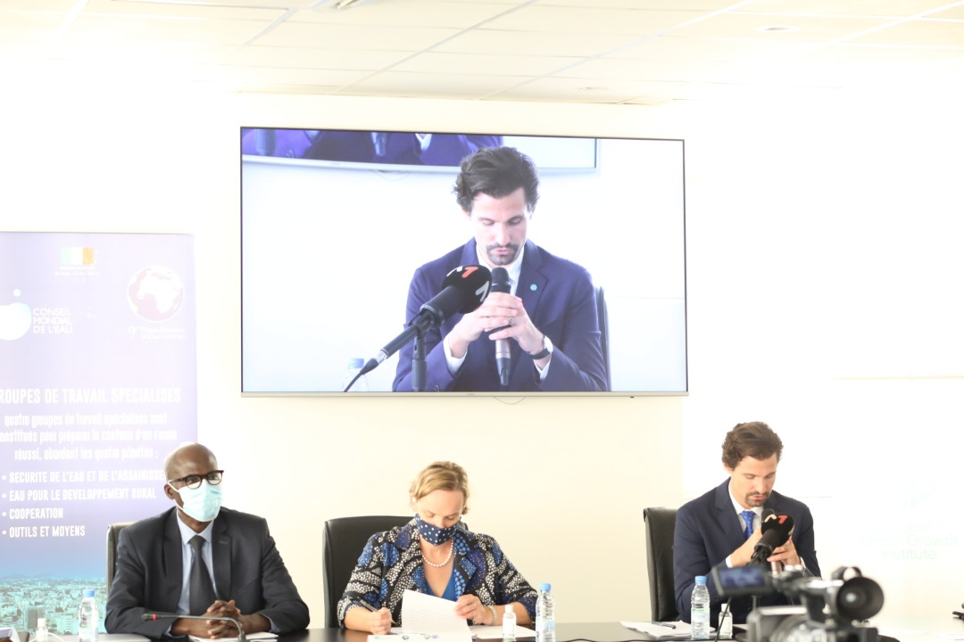

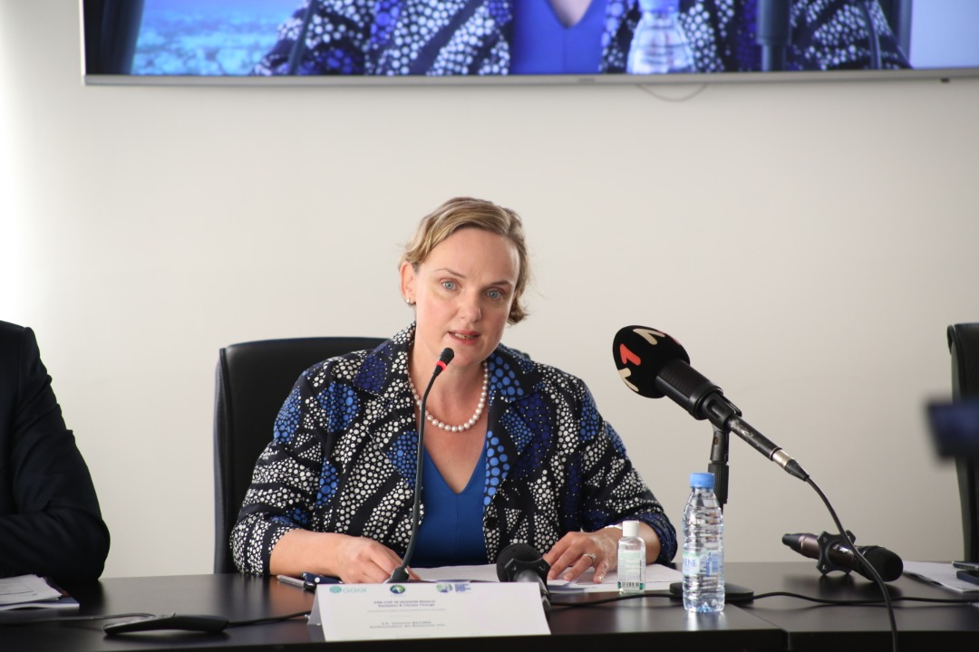

VII. Photos - Sessions I and II

